**Comparison Between Electric and Traditional Cars**

By Willow Rickman



***Electric Cars***

Electric cars function by plugging into a charge point and taking electricity from the power grid of an area. They store the electricity in rechargeable batteries that power an electric motor. Electric cars accelerate faster than vehicles with traditional fuel engines. All the energy that is put into the car is then used to power and move the car.

Pros of an electric car:

1. 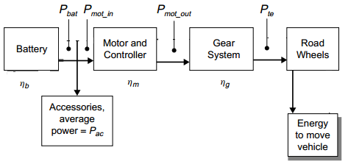Electric cars are very energy efficient.
2. Electric cars produce very little emissions.
3. They are low maintenance.

Cons of electric cars:

1. Even though its energy efficient, they can’t travel far.
2. “Filling up” the car takes much longer than that of regular cars.
3. Electric cars can be more expensive.

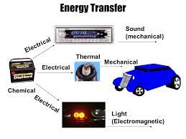There are however environmental impacts of electric cars, the batteries are made of rare metals and creating the actual car makes lots of pollution to the surrounding environment.

The diagram on the right depicts the energy transformations of the car in a simplistic way. Chemical, kinetic, electric, thermal, light, and sound are the energy transformations created by the vehicle.

***Traditional cars***

Traditional or gas cars typically use a spark-ignited internal combustion engine. In a spark-ignited system, the fuel is injected into the combustion chamber and combined with air. The air and the fuel are mixed and then is ignited by a spark from the spark plug. This produces energy that allows for the car to go.

pros:

1. Better power Economic price tag
2. Low maintenance cost Better agility (acceleration and speed)
3. 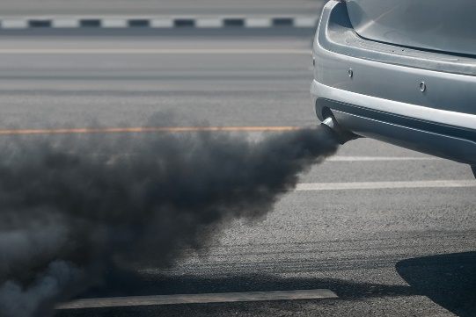easy to fill up and fuel again.

cons:

1. Harmful emissions Low mileage,
2. Gas vehicles have tailpipe emissions.
3. Gas vehicles contribute to toxic waste. Leftover oil, fluid, etc. is not biodegradable.

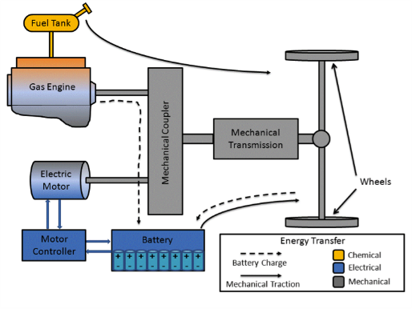 Burning gasoline fuel creates harmful by products like nitrogen dioxide, carbon monoxide, hydrocarbons, benzene, and even formaldehyde. These vehicles also emit carbon dioxide, the most common greenhouse gas. This adds to the carbon footprint of our planet. So, these cars have a very negative impact on the environment.

Gas cars transform chemical energy into kinetic energy by igniting the petrol(chemical) from the fuel tank. This ignition causes the car to move which is where it is turned into kinetic energy. The diagram on the left displays this action.

***What’s Better?***

There are many pros and cons to both types of cars, like the difference in prices, distance able to travel and fuelling stations. If you are looking for a cheap car option that travels long distances then a fuel-based car is better, but if you are wanting to lessen your carbon footprint then electric cars are better. They both equally have their own pros and their own cons. The making of both cars adds to the carbon footprint. The accessibility for charging stations for electric cars are much harder to find now, that is until electric cars become more popular and affordable for all.

***References and links***

* <https://www.google.com/url?sa=t&rct=j&q=&esrc=s&source=web&cd=&cad=rja&uact=8&ved=2ahUKEwja5r21hrn5AhUhoWMGHe30CuIQFnoECAoQAw&url=https%3A%2F%2Fwww.energysage.com%2Felectric-vehicles%2F101%2Fpros-and-cons-electric-cars%2F&usg=AOvVaw3CiKErbmYe3A1EMDhDfHkd>
* <https://www.google.com/url?sa=t&rct=j&q=&esrc=s&source=web&cd=&cad=rja&uact=8&ved=2ahUKEwja5r21hrn5AhUhoWMGHe30CuIQFnoECA4QAw&url=https%3A%2F%2Fwww.edfenergy.com%2Ffor-home%2Fenergywise%2Fhow-do-electric-cars-work%23%3A~%3Atext%3DElectric%2520cars%2520function%2520by%2520plugging%2Cthey%2520feel%2520lighter%2520to%2520drive.&usg=AOvVaw2ItZoY5r6drZd-QnuB2Uy8>
* <https://www.researchgate.net/profile/Joycer-Osorio-2/publication/234840598/figure/fig2/AS:340606791503876@1458218395504/Energy-Flow-of-the-Electric-Vehicle-5.png>
* <https://www.google.com/url?sa=t&rct=j&q=&esrc=s&source=web&cd=&cad=rja&uact=8&ved=2ahUKEwiK7qDoibn5AhWn9zgGHSXoBrIQFnoECDEQAw&url=https%3A%2F%2Fypte.org.uk%2Ffactsheets%2Felectric-cars%2Fwhat-are-the-downsides-to-electric-cars&usg=AOvVaw2w49xLzlK9kXzXTrKnZhTZ>
* three pros of gas cars - Google Search
* <https://www.online-sciences.com/the-energy/the-energy-transformation-inside-the-cars/>
* <https://www.google.com/url?sa=t&rct=j&q=&esrc=s&source=web&cd=&cad=rja&uact=8&ved=2ahUKEwiZxP6d2L35AhV83jgGHQnDCA0QFnoECAoQAw&url=https%3A%2F%2Fwww.wheelsforwishes.org%2Fnews%2Felectric-car-vs-gas-car-pros-and-cons%2F&usg=AOvVaw0dQKCGM7uo7KR15o-nyyyv>
* <https://www.google.com/url?sa=t&rct=j&q=&esrc=s&source=web&cd=&cad=rja&uact=8&ved=2ahUKEwid0qbD2L35AhUBDrcAHWdNCMcQFnoECAUQAw&url=https%3A%2F%2Fecology.wa.gov%2FIssues-and-local-projects%2FEducation-training%2FWhat-you-can-do%2FReducing-car-pollution%23%3A~%3Atext%3DBurning%2520gasoline%2520and%2520diesel%2520fuel%2Creduce%2520pollution%2520from%2520motor%2520vehicles.&usg=AOvVaw15u0iCY5u-7uZd1_Rw5ue->
* <https://www.google.com/url?sa=t&rct=j&q=&esrc=s&source=web&cd=&ved=2ahUKEwiM6aD12L35AhVv3TgGHVFDD9kQFnoECAsQAw&url=https%3A%2F%2Fstileapp.com%2Fstatic%2FCLL%2520handouts%2FLesson_054_handout.pdf&usg=AOvVaw2TMH1dX4zyMlpHD3mgsgkh>
* https://sitn.hms.harvard.edu/flash/2012/vehicles/
* <https://www.hsph.harvard.edu/news/press-releases/decreased-vehicle-emissions-linked-with-significant-drop-in-deaths-attributable-to-air-pollution/>